Mechanical Technical Report Three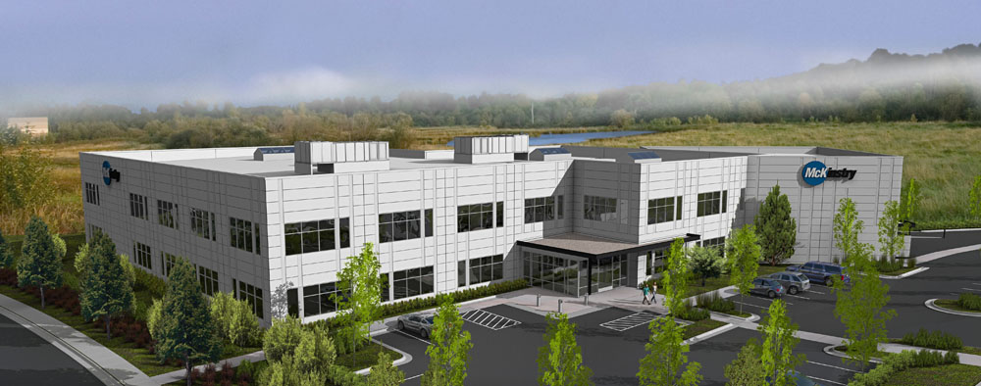
McKinstry Oregon Headquarters
Alex Wyczalkowski November 21, 2008

Prepared for
Dr. Jelena Srebric, Ph.D.
Associate Professor of Architectural Engineering
The Pennsylvania State University
Table of Contents

1 Executive Summary 3

2 Building and Mechanical System Overview 4

3 Design Objectives and Requirements 6

4 Energy Sources and Rates 7

5 Site Factors and Design Conditions 7
5.1 Site Factors 7
5.2 Rebates and Tax Incentives 8
5.3 Design Conditions 8

6 Ventilation Requirements 9

7 Heating and Cooling Loads 9

8 Annual Energy Use 10

9 Mechanical System Schematic Drawings 11

10 Major Equipment 12

11 System Operation Description 14
11.1 Air Handling Unit 14
11.2 Fan Terminal Units 15
11.3 Heat Recovery Chiller and Well System 15

12 Mechanical System First Cost and Lost Space 16

13 Mechanical LEED Analysis 17
13.1 Energy and Atmosphere Credit 1 17
13.2 Other LEED Credits 19

14 Overall Evaluation of System 20

15 References 21

16 Appendix A: Portland Design Conditions 22

17 Appendix B: System Cost Breakdown 23

18 Appendix C: LEED Project Checklist 24
1 Executive Summary
McKinstry Oregon Headquarters is a 50,590 square foot, 2 story office building. It began construction in March 2008 and is scheduled for completion in March 2009. It is located in Northeast Portland, overlooking the Columbia River. The building contains 2 floors of offices, as well as a full kitchen, showers, and a small weight room for employees. There is also a large warehouse at the west end of the building which is not ventilated.
The design of the Headquarters was dictated by three main factors: sustainability, comfort for tenants, and economy. Section 3 describes how each of these three factors needed to be balanced to make the building work well.
LEED Certification was very prominent in the design of the building as well. In Section 5.2 shows tax credits totaling over $600,000 that can be achieved by a green building in Oregon. This value is a large incentive to push sustainability and energy efficiency.
The tax credits may be desperately needed for McKinstry. Based on the proposed energy model (Section 8) compared to the ASHRAE baseline model (Section 13), and large upfront costs of the premium system (Section 12), there isn’t a large change in energy savings. However, Section 13 also discusses possible errors in the models that could attribute for the small savings.
Detailed descriptions of building systems and operations can be found in Sections 2 (Overview of systems), Section 9 (Schematic Drawings), Section 10 (Mechanical Equipment), Section 11 (System Operation), and Section 12 (First Cost and Lost Space). First cost for the mechanical system is $1,394,511.

2 Building and Mechanical System Overview

McKinstry Oregon Headquarters is a $15.5 million project which is scheduled for completion March 1, 2009. This includes two buildings. The only building of interest is the office building, as the other is simply a warehouse. Costs for the 50,590 square foot office building total $11.1 million dollars.
The headquarters is a 2 story office building. The office is laid out in a simple rectangular grid. At the West end of the building a full height 1 story warehouse attaches at a rotated angle.
Vestibule 484 sf
Office
23,000 sf
per floor
sf
4400
Ware
House

N

Figure 2.1. Building Footprint

The flat, tilt-up concrete walls have vertical and horizontal lines to break the long straight façade. Approximately 30% of the office façade is glazing and windows are double glazed. The base of the building is a reinforced concrete slab (there is no basement). The exterior walls are backed by 3-5/8” metal studs and 3.5” batt insulation. A built-up roof with 3” rigid insulation and 1.5” metal decking tops off the structure. The roof also has several translucent skylights for natural day lighting. The remaining lighting in the building is fairly standard with 100% fluorescent fixtures.

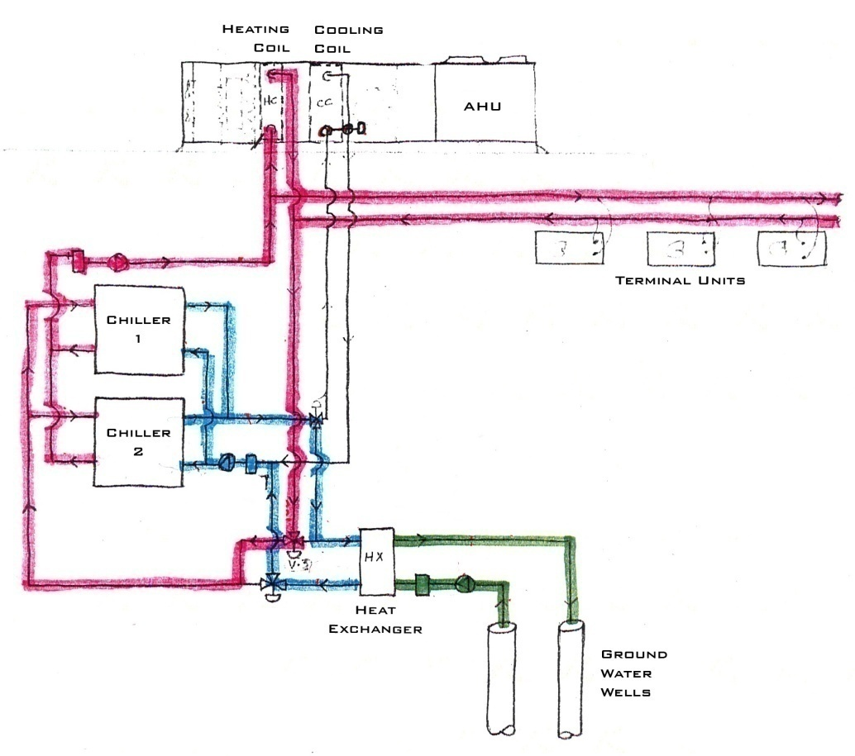
Figure 2.2. Waterside system, shown in heating mode. (McKinstry Design Documents)

The central plant of the building is a heat recovery chiller that is used for both heating and cooling. The mechanical system also includes an open loop ground source heat pump. Ground water accepts heat from the condensing water in cooling mode and provides heat to the evaporator water in heating mode. Evaporator side water and condenser side water are piped to the cooling and heating coils in the air handling unit, respectively. A single rooftop AHU (with VFD) distributes air via ducts to the office section of the building. Series VAV boxes with hot water reheats are located throughout the office. Also, an airside economizer can provide cooling on light load days. Two hot water unit heaters keep the warehouse warm in the winter. Heating is provided by the hot water loop and there is no cooling or ventilation. Linear diffusers condition the vestibule at the front of the building. More details can be found in Section 9.

3 Design Objectives and Requirements

Many factors go into the design of a mechanical system. Before choosing the correct system, a designer must first know what are the owner’s and occupant’s needs. In the McKinstry Oregon Headquarters, it is a combination of sustainability, comfort, and economy.
First and foremost, the McKinstry wanted to make sure their new building received LEED Certification. According to McKinstry designers, LEED has become the industry standard. Achieving certification is seen no longer as a perk, but a necessity. At the beginning of design, McKinstry looked into several sustainable solutions. One of which was on-site wind energy or solar energy. The designers also wanted to save water by harvesting rainwater. This grey water would supply all of the toilets and urinals in the building. The mechanical system is an open loop ground source heat pump. In a metaphorical way, the open loop system, like the roots of a tree, gets its energy from the earth. This can provide substantial savings on energy. Finally, being a mechanical company, they find an aesthetic to their work and chose to leave the ductwork exposed throughout the building.
Tenants’ comfort was very important from the beginning of design. A comfortable employee is a more productive employee, so the designers wanted to make sure every effort was taken to maintain a comfortable environment inside the building. On the mechanical side, indoor temperatures were set to very comfortable temperatures (70ºF in the winter and 74ºF in the summer). Some buildings in the Portland area would actually raise their summer setpoint to as high as 80ºF to save energy. Windows in the room were placed higher on the walls to decrease direct sunlight onto the work plane. The building also includes a full kitchen with stove and hood system, showers for those who bike to work, and a weight room. All of this creates a welcome atmosphere to employees and encourages employees to spend time together on breaks.
Finally, just as in virtually any project, hard dollars step in and dictate which ideas are feasible and which ideas are pipe dreams. Throughout the project, total costs dwindled from about $20 million to $15 million. Several ideas such as solar and wind power were scrapped (the wind power had a 30+ year payback). Rainwater harvesting was reduced from supplying all the toilet grey water to being a supplemental system. As with any building, the greatest challenge is to produce an aesthetic, functional building on a budget.
4 Energy Sources and Rates

Electricity is provided to the building by Portland General Electric (PGE). The rate code is “PGE 83S 3P N-TOU Lrg N-Res Elec”. Essentially this means it is large non-residential electric. The following is a general formula for charges:
Monthly Charge = [$25 + $.05298*(kWh usage) + $2.27*(kW demand)]/.8
Where .8 is the Power Factor adjustment. Average cost comes to about $.08/kWh
Natural Gas is provided by Northwest Natural. The code is “NW Natural-OR 3-Comm Uniform”. The following is a general formula for charges:
Monthly Charge = $8 + $1.198/therm. Average cost comes to about $1.23/therm

5 Site Factors and Design Conditions

5.1 Site Factors

The footprint of the building is strongly dictated by the Environmental Protection Zone which surrounds the property. In this zone, there are setbacks which do not allow anything to be built, no alterations to the landscape, and no overhangs. In addition to these requirements, there are strict regulations in Portland due to a strong environmentalist lobby. McKinstry was still able to get permits for an open loop ground source heat pump despite the system being fairly intrusive to the environment.

5.2 Rebates and Tax Incentives
In Oregon, there are two different organizations which provide tax incentives. ODoE (Oregon Department of Energy) and ETO (Energy Trust of Oregon) both give rebates for constructing energy efficient buildings. While there are many ways to get credit from these organizations, McKinstry chose to go the LEED path, where they get credit based on their LEED points and rating. The following tables show rebates available from ODoE and ETO.
Table 5.2.1. ODoE Business Energy Tax Credit (BETC) for LEED Buildings
 | Incentive per SF by LEED Rating
Area | Silver | Gold | Platinum | Total for HQ*
First 10,000 SF | $10.00/SF | $13.57/SF | $17.86/SF | $135,700
Next 40,000 SF | $5.00/SF | $5.71/SF | $9.29/SF | $228,400
>50,000 SF | $2.00/SF | $2.86/SF | $5.71/SF | $1,687
Total Incentive: |  |  |  | $365,787
*50,590 SF, assuming Gold Rating
Table 5.2.2 ETO Tax Credits for LEED Buildings
ENERGY AND ATMOSPHERE
Credit | Name | Total Rebate
Credit 1 | Percentage Improvement compared to ASHRAE 90.1 | Up to $300,000
Credit 3 | Enhanced Commissioning | Up to $20,000
Credit 5 | Measurement and Verification | Up to $20,000

5.3 Design Conditions
The following table shows design conditions for McKinstry Oregon HQ. See Technical Report II (Wyczalkowski) for full assumptions about indoor conditions and Appendix A of this report for full outdoor design conditions for Portland, OR.
Table 5.3.1. Indoor and Outdoor Design Conditions
Design Condition | Indoor (occupied) | Indoor (unoccupied) | Outdoor
Heating | 70°F | 65°F | 27.0°F (DB, 99%)
Cooling | 74°F | 78°F | 86.6° F (DB, 1%)

6 Ventilation Requirements
ASHRAE Standard 62.1 – 2007 sets forth guidelines “to provide indoor air quality that is acceptable to human occupants and that minimizes adverse health effects.” Section 6 of the ASHRAE Standard provides the Ventilation Rate Calculation Procedure. Analysis of McKinstry Oregon Headquarters found a minimum outdoor air of 5,109 CFM, or 14% outdoor air. This is less than the air handling unit’s minimum outdoor air supply of 5,500 CFM. In summary, McKinstry Oregon Headquarters complies fully with ASHRAE Section 62.1 – 2007. Complete analysis and calculation can be found in Technical Report I (Wyczalkowski).

7 Heating and Cooling Loads

The following table from Tech Report II (Wyczalkowski) shows results from eQUEST model and design documents. Peak heating and cooling loads are highlighted.
Table 7.1. Energy Model Loads vs Design Document Loads
 | eQUEST model* | Design Documents
Cooling Peak | 18.03 BTU/(hr*sf) | NA
sf/ton | 665.5 | 503
Heating Peak | 19.55 BTU/(hr*sf) | NA
Supply Air at Peak Flow | .82 CFM/sf | NA
Min Outside Air/person | 33.88 CFM | 23.09 CFM
*See Technical Report II for full analysis

8 Annual Energy Use

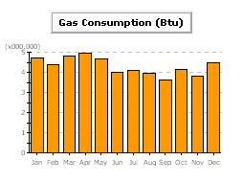
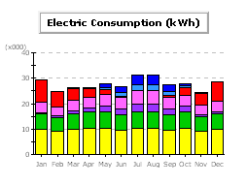
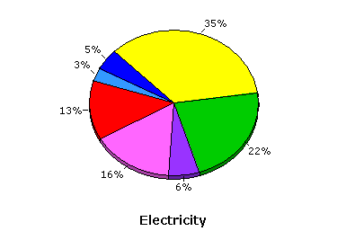

Figure 8.1. Electric consumption, gas consumption, and electricity breakdown

Table 8.1. Electric and gas consumption
=(Therms x10)
9 Mechanical System Schematic Drawings

Figure 9.1. Water Side System in Heating Mode
Figure 9.2. Water Side System in Cooling Mode
Note position of
3-way valves
Air Side System:
A single rooftop AHU (with VFD) distributes air via a medium velocity duct system to the office section of the building. There are no drop ceilings in the offices, as to expose the duct work. Thus there is no plenum and square diffusers distribute air from the ceiling. Series VAV boxes with hot water reheats are located throughout the office. Return air is also ducted.
Water Side System:
Cooling Mode
with Hot Water Reheat
Water Side System:
Heating Mode
with Airside Economizer
10 Major Equipment

Table 10.1. Pump Details
PUMPS | Well Water Supply (P-1, P-2 Alternate) | Chilled Water  (P-3, P-4 Alternate) | Condenser Water  (P-5, P-6 Alternate)
Location | Well | Mechanical Room | Mechanical Room
GPM | 200-300 | 140 | 130
Total Head (ft) | 128-153 | 81 | 90
VFD | Yes | No | No
Motor HP | 25 | 7.5 | 7.5
Efficiency | ASHRAE Table 10.8 | ASHRAE Table 10.8 | ASHRAE Table 10.8

Table 10.2. Chiller Details
CHILLER – CH-1
Multi-stage, water cooled
Location | Mechanical Room
Operating Weight | 4100 lbs
Compressor | Rotary Scroll
HEATING
kBTUh | 1,303
COP | 4.1
Power Input | 94.3 kW
CHW EWT/LWT | 52/38
CDW EWT/LWT | 100/120
COOLING
kBTUh | 1,722
Capacity | 123.5 tons
EER | 21
Power Input | 70.6 kW
CHW EWT/LWT | 69.2/48
CDW EWT/LWT | 60/86.8

Table 10. 3. Heat Exchanger Details
HEAT EXCHANGER – HX-1
Location | Mechanical Room
Type | Plate and Frame
Well Water GPM | 250
Chilled Water GPM | 140
Heating Water GPM | 130
WW EWT/LWT | 50/40 (Heating)
WW EWT/LWT | 59/74 (Cooling)
Chilled Water EWT/LWT | 38/48 (Heating)
Heating Water EWT/LWT | 82/62 (Cooling)
Table 10.4 Air Handler Details
AIR HANDLING UNIT – AHU-1
Location | Rooftop
Supply Fan | Plug, Blow Through
Supply CFM | 35,800
Supply BHP/HP | 44.7/50
Supply Motor Eff | Premium
Supply VAV Control | VFD
Minimum OA | 5,500 CFM
Exhaust CFM | 35,800
Exhaust BHP/HP | 12.75/15
Exhaust Motor Eff | Premium
Exhaust VAV Control | VFD
Cooling MBH | 970 Sens/1065 Total
Chilled Water EWT/LWT | 44/59.2
Cooling Coil EAT/LAT | 79DB,62WB/ 52.3
CW GPM | 140
Heating MBH | 1122
Heating Coil EWT/LWT | 120/100
Heating Coil EAT/LAT | 69/98
HW GPM | 112
Unit Size | 16,000 lbs

Table 10.5. Hot Water Unit Heater Details
Hot Water Unit Heater – UH1
Location | Warehouse
Heating Coil EWT/LWT | 120/100
Output MBH | 100
Fan Motor HP | .09
Weight | 100 lbs
Table 10.6. Fan Terminal Unit Details
Fan Terminal Units – FTU-#
Type | Series
VAV | Yes
Count | 35 Total
Reheat | Hot Water
Fan Motor | .5-.75 HP
Duct | Round, No Plenum
Fan CFM | 440-1300 CFM

Table 10.7. Exhaust Fan Details
EXHAUST FANS | EF-1 | EF-2 | EF-3 | EF-4
Location | Toilet Room | Data Room | Locker Room | Elevator Room
Fan Type | Centrifugal | Centrifugal | Centrifugal | Centrifugal
CFM | 1200 | 400 | 1080 | 400
HP | .33 | .125 | .33 | .125
Efficiency | Code minimum | Code minimum | Code minimum | Code minimum

11 System Operation Description

11.1 Air Handling Unit
Mode Control: Occupied/Unoccupied operation is according to a user determined schedule. During unoccupied mode, a push button on a selected room sensor can operate the unit in occupied mode for a set period (initially 2 hours). The system includes an equipment stagger start function to minimize electrical demand. Normal operation can also be overridden by the fire alarm system.
Supply Fan Control: In the medium pressure system, “the goal is to maintain duct static pressure as low as possible. This is achieved by maintaining the critical zone air valve between 85%-95% open.” (McKinstry RFP) The Building Management System (BMS) senses the damper position of all Fan Terminal Units in the building. The unit that is most open is critical. If it’s less than 85%, the BMS tells the VFD to slow down the supply fan, increasing CFM. If it is more than 95%, the VFD speeds up the supply fan. The design duct static pressure set-point is 1.0”.
Supply Air Temperature Control: 3 options
- OSA < 50ºF or Return Air < 68ºF: “Heating coil valve shall modulate to temper supply air temperature as necessary”
- Economizer Mode (OAT < SAT-Fan Heat): The BMS modulates OSA and RA dampers to maintain SAT setpoint. If supply air reaches 100% OSA (airflow monitoring station), the BMS opens the chilled water valve.
- All other times: SAT is reset up or down 1º every 10 minutes based on “served zone cooling loop output average value and hot zone count.”
Minimum Outside Air CFM Calculation: Sequence is based on ASHRAE standard 62-2001 Section 6.1.3.1 Multiple Spaces

11.2 Fan Terminal Units
Mode Control: See Mode Control for Air Handling Unit, Section 11.1
Occupied Mode: First stage of heating has the primary damper open to minimum. Second stage of heating opens and modulates hot water valve. If zone temperature is too high, the heating water valve will close and the primary air damper will modulate open to maintain set-point. Supply fan is always on.
11.3 Heat Recovery Chiller and Well System
Mode Control: BMS enables operation of chiller to coincide with AHU and FTUs. Heating and cooling modes are determined by number of zones that require heating or cooling. Normal operation can be overridden by fire alarm system.
Cooling Mode: Chiller will operate in cooling mode when 60% of the zones are “hot zones” (i.e. require cooling), AND the OSA > 55ºF. Condenser and evaporator water circulation pumps first energize on call for cooling. The chiller will then operate once proof of flow is met. The chiller will maintain 44ºF CHW supply temperature. Three way valves V-1, V-2, and V-3 will be diverted as shown in Figure 9.2. Well water pumps energize and maintain full flow through heat exchanger.
Heating Mode: The Chiller operates in heating mode when 60% of the zones are “cold zones”. Like in cooling mode, the chiller will not turn on until proof of flow is met in the CDW and CHW loops as to protect the chiller. The chiller will maintain 120 º F heating water supply temperature. Three way valves V-1, V-2, and V-3 switch positions as shown in Figure 9.1. Well water pumps turn on similar to cooling mode.

12 Mechanical System First Cost and Lost Space

Estimates for mechanical system first cost come to $1,394,511. This estimate consists of two numbers, a Market Base ($644,842) and a Premium Price ($749,669). Market Base is an estimate of the cost of a lowest-first cost system. The Premium Price includes upgrades to the building like well drilling, Heat Pump System, hot water to fan terminal units, and Integrated Technology Service (ITS). Full cost breakdown can be found in Appendix B of this report.
Lost space totals 986 SF. The mechanical room is 656 SF. In addition, a mechanical shaft occupies an additional 30 SF on the second floor. A single air handling unit is located on the roof and occupies 300 SF of roof area.
13 Mechanical LEED Analysis

13.1 Energy and Atmosphere Credit 1
ASHRAE Model Assumptions
The following table shows the differences between the as-proposed model from Technical Report 2 (Wyczalkowski) and the ASHRAE Baseline model created for this report.

Table 13.1.1. Proposed vs ASHRAE Model
System | Proposed Model | ASHRAE Baseline*
Lighting | .81 W/SF | 1.1 W/SF
HVAC System | Customized Heat Recovery  Chiller with Open Loop GSHP | Packaged Rooftop Heat Pump
Economizer | Default | High Limit = 75ºF
Warehouse Heat | Hot Water Unit Heater | Electric Resistance
DHW Heater | 95 % efficient | 80% efficient
Exterior Walls | R-13 (non-continuous) | R9.5 (continuous)
* All assumptions for Baseline model are from ASHRAE Standard 90.1 Appendix G

eQUEST Simulation Results
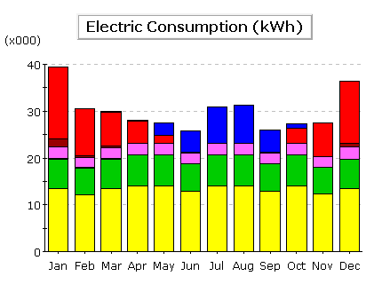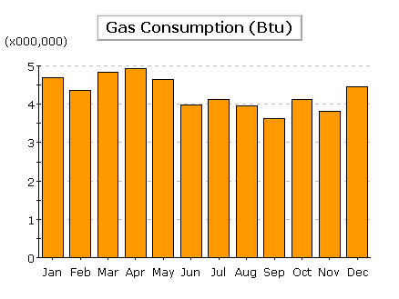
Figure 13.1.1. Electric consumption, gas consumption, and electricity breakdown

Table 13.1.2. Electric and gas consumption
Comparing the total numbers from the two models, there is not a large difference in overall energy usage. Electric consumption reduced from 360,500 kWh to 331,500kWh. This is an improvement of only 8%. However, after looking at the numbers more closely, there are some interesting discrepancies. In the original model, Ventilation Fans accounted for 51,860kWh (more than Heating), where as it only totals 28,780kWh in the Baseline Model. Ventilation should not be more in the proposed model; in fact it should be lower because the proposed has VAV and the baseline uses CAV. If the ventilation usage is lowered, we get a total improvement of 14.4%. This amounts to 2 LEED points. In addition, pump energy is over 40 times higher in the proposed model. The gas consumption is identical in both models, even though the proposed model has a more efficient heater (95% versus 80%). In reality, the percent improvement is probably greater than shown in this report.

13.2 Other LEED Creditd
Water Efficiency Credit 2: Innovative Wastewater Technologies
The McKinstry Oregon Headquarters utilizes Rainwater Harvesting to supplement water usage in toilets throughout the building. Originally designers wanted to build enough storage to be stand-alone. The winters in Portland are very wet, and summers are very dry, so a large amount of water would need to be stored to last throughout the summer. However, due to payback issues, the designers decided to have the system only be supplemental.
Energy and Atmosphere Credit 3: Enhanced Commissioning
McKinstry which self performs the mechanical design and construction for the Oregon HQ was able to provide commissioning as well. However, they hired a 3rd party to commission the building to work with them and ensure that the commissioning was done properly.
Energy and Atmosphere Credit 5: Measurement & Verification
As standard practice on all of their projects, McKinstry provides Measurement and Verification on all of their projects. This ensures that all the installation and commissioning was done correctly. Should there be any problems with the systems, measurement and verification assures they will be addressed.
McKinstry Designers have provided a LEED checklist for their building. They are attempting to achieve LEED Gold Rating. See Appendix C for the full checklist.
14 Overall Evaluation of System

Overall, McKinstry Oregon Headquarters is a fairly efficient building. Although there are large internal loads in the building with lighting and equipment, the building is fairly well insulated and has an efficient mechanical system.
Space requirements in the building are fairly small. There is a small mechanical room in the warehouse and an AHU on the roof. There are only two significant pieces of equipment in the building, a chiller and the AHU. The heat recovery mode of the chiller eliminates the need for a boiler.
The building has a fairly expensive mechanical system. It comes at a premium of $749,669 over an industry standard system. Using an engineering economics equation, assuming a 6% interest rate per year, energy cost savings would have to be $54,425 per year to break even in 30 years. The system currently saves 52,050 kWh per year. Even at a generous $0.10/kWh, yearly savings are $5,205/year. As stated earlier, the results from the energy model seemed inaccurate, but energy savings would have to be significantly higher than modeled to give any sort of reasonable payback. Note that increased LEED points will also give a significant rebate.
A significant portion of the premium cost is the open loop GSHP system. Drilling and Permits alone cost $180,000. The Heat Pump System costs an additional $400,000. Hot water reheat in the VAV units saves money, but comes at a cost of $125,000. Full breakdown of costs can be found in Appendix B.
The wells may also have some issues with maintainability. If a pipe bursts underground, it can become a large maintenance issue, as the wells go over 100 ft into the ground. Since the system is open loop, there is also a risk that the pumps may bring in particles that may clog the system. This would also be a large maintenance issue.
The VAV airside system is fairly commonplace today. There are several newer systems that can be implemented instead such as under floor distribution systems, radiant panels, and even DOAS systems.

15 References

ASHRAE. 2005, ANSI/ASHRAE, Portland Design Conditions. American Society of Heating Refrigeration and Air Conditioning Engineers, Inc., Atlanta, GA. 2007
ASHRAE. 2007, ANSI/ASHRAE, Standard 90.1 – 2007, Energy Standard For Buildings. American Society of Heating Refrigeration and Air Conditioning Engineers, Inc., Atlanta, GA. 2007
McKinstry. 2008. Design Documents. McKinstry, Seattle, WA. 2008
McKinstry: Portland Headquarters Building One. 2008. Prepared by Myer, Patty. Request For Proposal: Controls. McKinstry, Seattle, WA. 2008
Wozniak, Aaron. 2008. Personal Communication. Portland, OR. 2008
Wyczalkowski, Alex. 2008. Technical Reports 1 & 2. The Pennsylvania State University. 2008

16 Appendix A – Portland Design Conditions

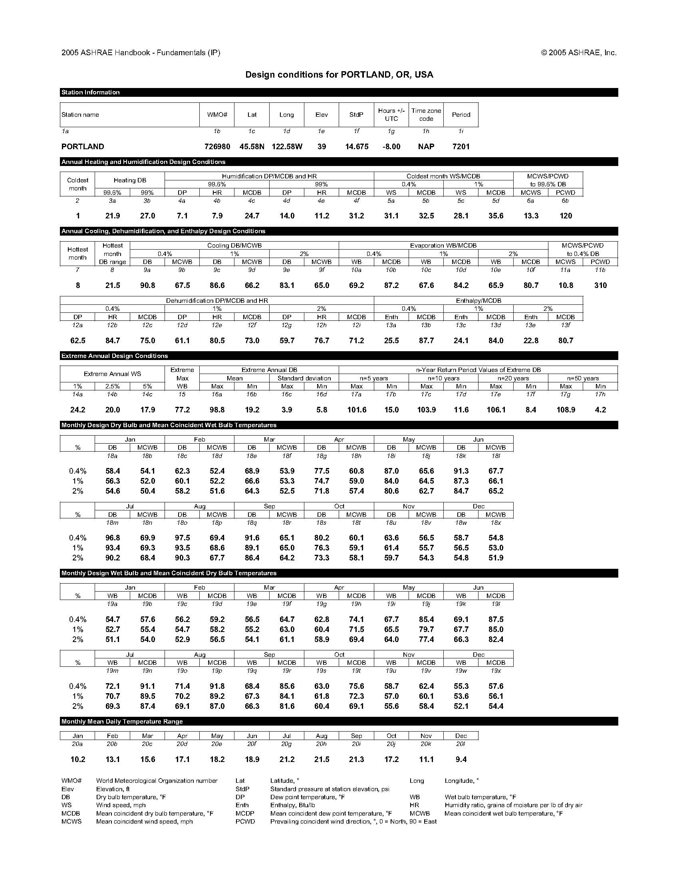
17 Appendix B – System Costs Breakdown
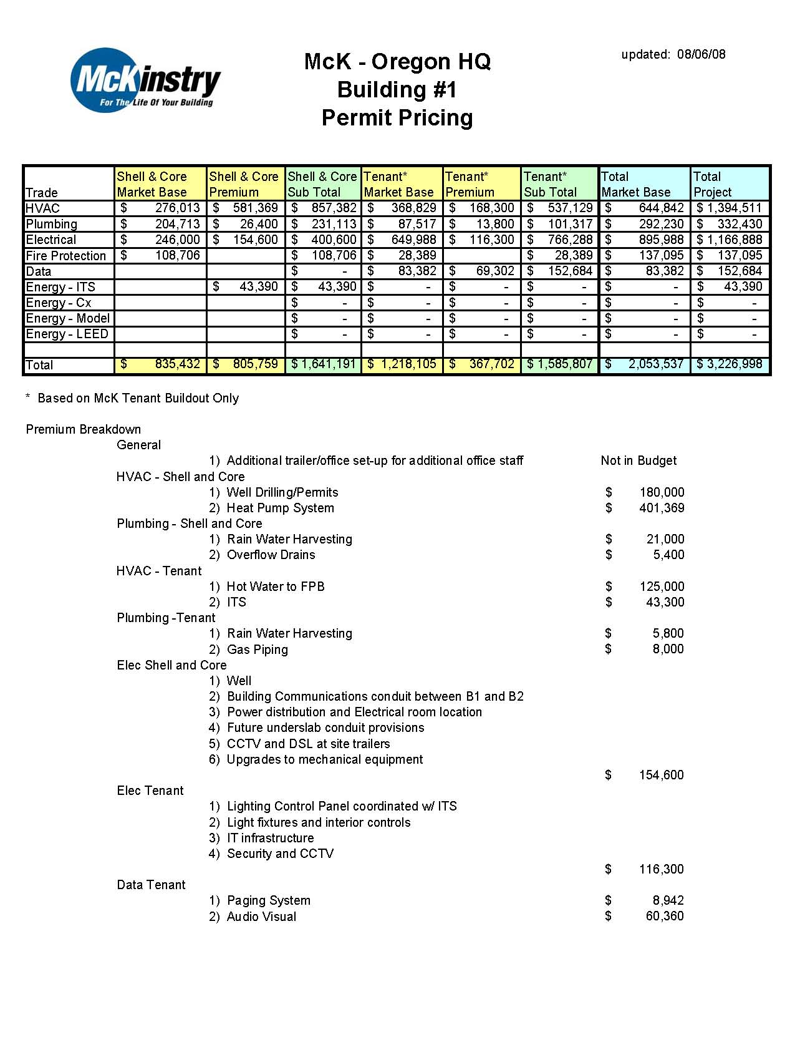

18 Appendix C – LEED Project Checklist

